Chapter 5, Problem 72

Find the load voltage v_{L} in the circuit of Fig. 5.98.

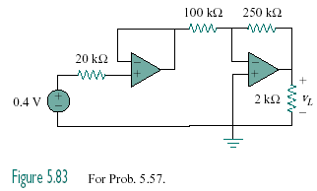

1.8 V

Figure 5.98
For Prob. 5.72.

